A school curriculum by the Research Group on Introduced Species, 2007
www.rgisbc.com
Contact: rgis@qcislands.net

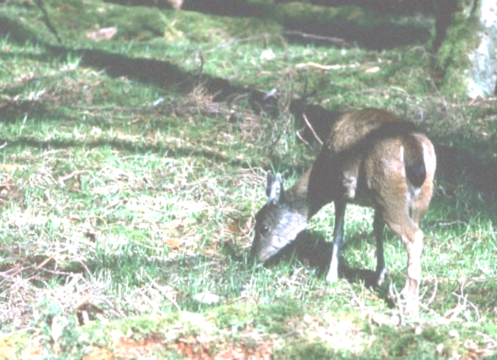

What is wrong with deer on Haida Gwaii?

Forests of Haida Gwaii

- Haida Gwaii is an archipelago. It consists of a great number of islands, big or small.

- Most of these islands are covered with forest.

- The islands are home to many plants, insects, birds… … and deer.

- While plants, insects and birds had always been present on Haida Gwaii, deer arrived only 130 years ago.

Deer on Haida Gwaii

- Deer were introduced. People coming to settle on Haida Gwaii brought with them deer from the mainland to provide game meat.

- Deer were released in the wild. They managed very well on Haida Gwaii: the weather is never too cold, and, contrary to the mainland, there are no wolves that might hunt them. Deer have no predator on Haida Gwaii.

- 39 deer were introduced 130 years ago. Today, there must be between 150,000 and 200,000 deer on Haida Gwaii.

- Deer are herbivores. They feed on vegetation: grass, leaves and flowers. They are now very numerous on Haida Gwaii, and consequently, they eat a lot of plants.

- Deer never settled on a few islands. On these islands, vegetation grows so high and thick that you can hardly walk in the forest.
On the other islands, deer browse the vegetation. As a very big number of deer feed on each island, there very little plants left in the forest.

- Deer were not the only species to be introduced on Haida Gwaii.
  - Like deer, some species were introduced on purpose: Raccoons and beavers were introduced for fur trapping. Squirrels were introduced to gather cones for replanting trees.
  - Others were introduced as domestic animals and went wild, like cats, dogs or cattle (they are called feral animals).
  - Some were introduced unintentionally, like rats, which arrived in boats as stowaways.
  - Many plants were introduced as ornament or fodder for cattle. Some of them have become invasive.

Insects and birds on Haida Gwaii

Insects

- Many insects (like leafhoppers) are herbivores: they feed on plants.

- Other insects, (like bumblebees) are pollinators: they feed on nectar, a sugary liquid produced by flowers.

- Some insects (like some bettles) are predators: they feed on other animals, like other insects or gatropods.

- Others (like some wasps) are parasites: for example, they lay their eggs inside other insects.

Birds

- Birds can feed on fruits, seeds, nectar or insects.

- Many birds need deep vegetation to hide their nests and protect their eggs from predators (for exemple, bigger birds).

Why is deer introduction a problem on Haida Gwaii?

Plants, insects, and birds belong to the same ecosystem: they are all linked together because they all live in the forest.
They depend on each other for their survival.

- First, let’s observe what the relationships between plants, insects and birds are in the forest ecosystem.
- Then, we will observe what happens when too many deer are « added » to the ecosystem.

Forest without deer

All the elements of the deer-free forest ecosystem are represented on the scheme.
- Show how they depend on each other by using arrows
Example:
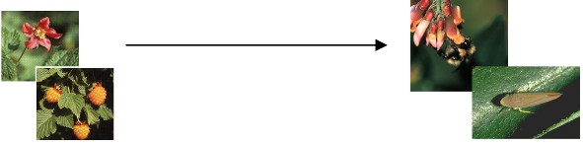

“Plants are useful to hebivorous insects and pollinators” (because they feed on them)

- Circle in green the elements that survive well in the deer-free forest
Example:
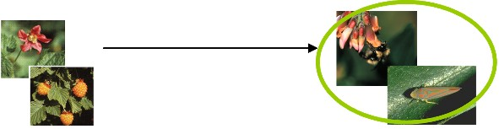
“Herbivirous insects and pollinators survive well in the deer-free forest” (because they feed on plants, which are abundant)

- Is it easy or difficult for egg predators to spot nests? Circle the correct answer on the scheme.

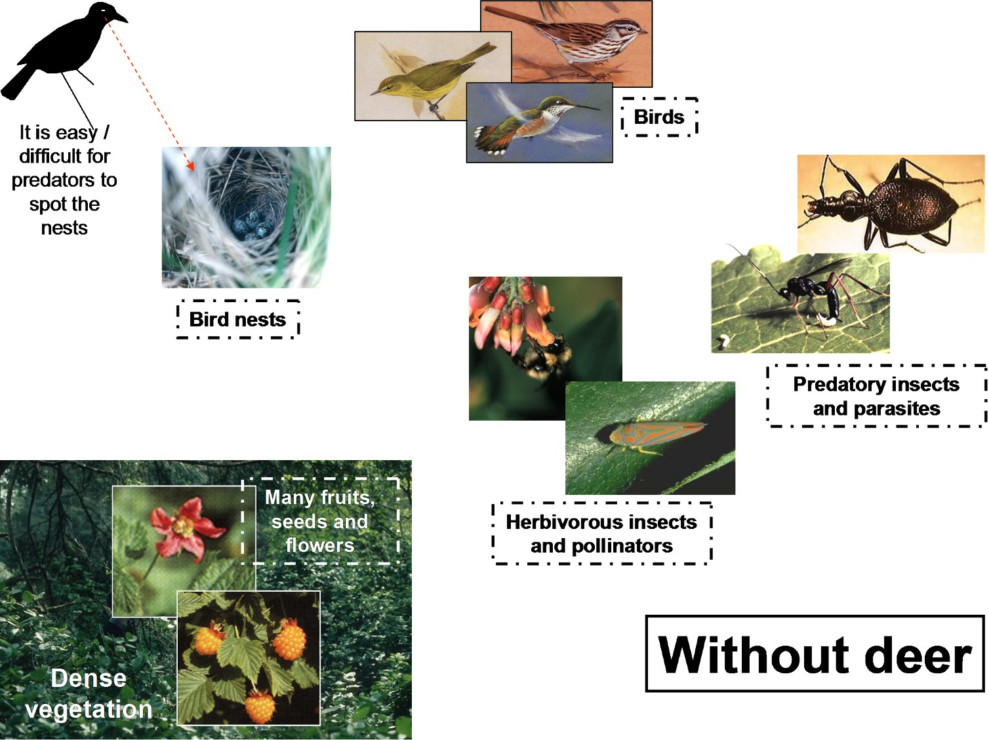

Forest with deer

All the elements of the deer-affected forest are represented on the scheme.
- The relationships between plants, insects and birds are still the same: reproduce the arrows that you have just drawn on the “deer-free ecosystem”.

- What changes is how the elements of the ecosystem survive when the ecosystem is affected by too many deer: circle in red the elements for which survival is difficult in the deer-affected forest.

- Is it easy or difficult for egg predators to spot nests? Circle the correct answer on the scheme.
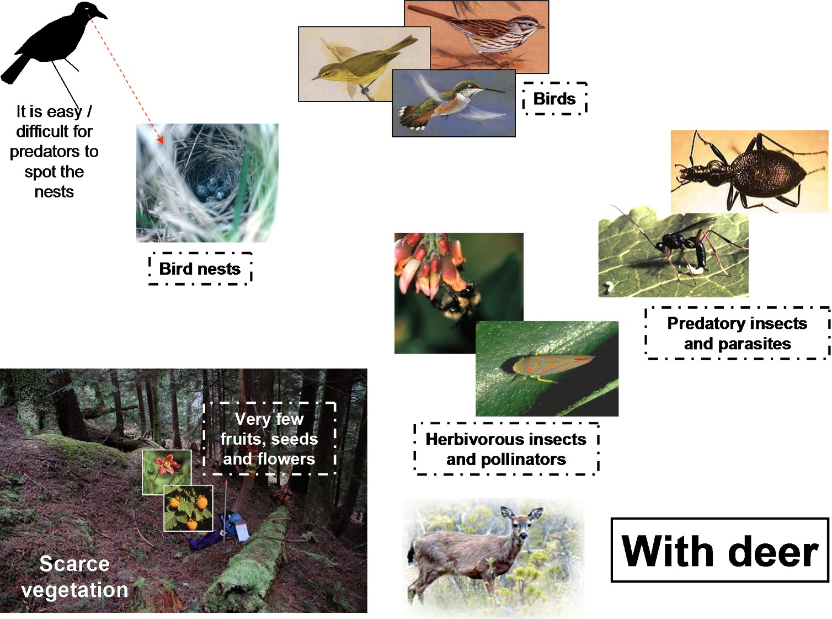

Direct and indirect effects of deer

- Deer have a direct effect on vegetation

  - Deer browse the plants in the forest, that is why the vegetation becomes scarce when too many deer are present on an island.

- But deer have many indirect effects on the other species living in the forest

  - Indirect effect on birds and insects feeding on plants
    - Deer browse the vegetation, which becomes scarce. → Birds and insects who feed on the vegetation do not have enough food to survive.

In the same way, describe the other indirect effects

  - Indirect effect on insects feeding on or parasiting other insects
……………………………………………………………………………………………………………………………………………………………………………………………………
…………………………………………………………………………………………………

  - Indirect effect on birds feeding on insects
……………………………………………………………………………………………………………………………………………………………………………………………………
…………………………………………………………………………………………………

  - Indirect effect on bird nests
……………………………………………………………………………………………………………………………………………………………………………………………………
…………………………………………………………………………………………………

- Although deer do not feed on birds or insects, they indirectly affect them through their direct effect on vegetation.

Because they have less to eat and fewer places where to hide from their predators:
- the number of birds and insects on deer-affected islands decreases
- the number of different species of birds and insects also decreases (only the species the less dependant on vegetation survive)

- Islands like these of Haida Gwaii are especially vulnerable to introduced species.
- Islands are isolated: native species are very often unique on the islands and can’t be found anywhere else. They are also very sensitive to new diseases.
- Islands are small: native species encountering introduced species cannot move away from the threat.
- Islands have fewer species and smaller populations than the mainland: these populations are quickly threatened by introduced species

How can we deal with introduced species?

- The consequences of species introductions on ecosystems are very difficult to forecast.

Introduced species can:
- Have a very hard time adapting to its new surrounding and not even survive
- Or find a place in the new area and become naturalized.

Naturalized species may:
  - Cause very little disturbance on the new ecosystem.
  - Or become a threat to the ecosystem and become invasive.

Invasive species can:
- feed on on native species
- compete with them for food or habitat
- carry new diseases
- damage the habitat
- or be itself an additional source of food

…resulting in the decrease in the populations of some native species and/or in the increase in the populations of other native species.
These changes may have impacts on the populations of other native species and on the global quality of the habitat.

- Introduced species have also cultural and economic impacts

On Haida Gwaii, deer browsing prevents Redcedars and other trees from growing normally.
- Redcedars are important to the Haida First Nation, who traditionnaly use redcedar for carving and weaving.
- Tree regeneration is important to logging industry, which needs to make sur that forest grows again after a cut.

- It is very difficult to get rid of introduced species once they are settled somewhere

- It has been suggested to introduce wolves on Haida Gwaii in order to reduce the population of deer. What do you think about it?
………………………………………………………………………………………………………………………………………………………………………………………………………………………………………………………………………………………………………
…………………………………………………………………………………………………
…………………………………………………………………………………………………

- Trying to control the spread of introduced species is not always easy and often very expensive.

- Therefore, we have to avoid any more species introduction. Nowadays, most of introduced species are introduced accidentally (stowaways on ships or in packages travelling all over the world, pets released in the wild or plants escaped from gardens).

We must all be careful when we travel or when we buy exotic plants or animals.

