A school curriculum by the Research Group on Introduced Species, 2007

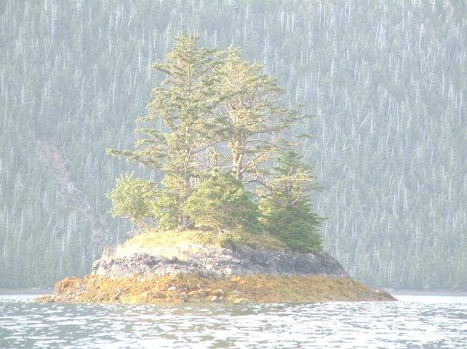

RGIS research on Haida Gwaii
http://www.rgisbc.com

www.rgisbc.com
Contact: rgis@qcislands.net
RGIS research on Haida Gwaii
http://www.rgisbc.com/research

History of deer colonization

- What is the principle of dendrochronology?

- How does a period of stress appear on a sequence of rings?

- How are tree and shrub growth and regeneration affected by a heavy browsing pressure?

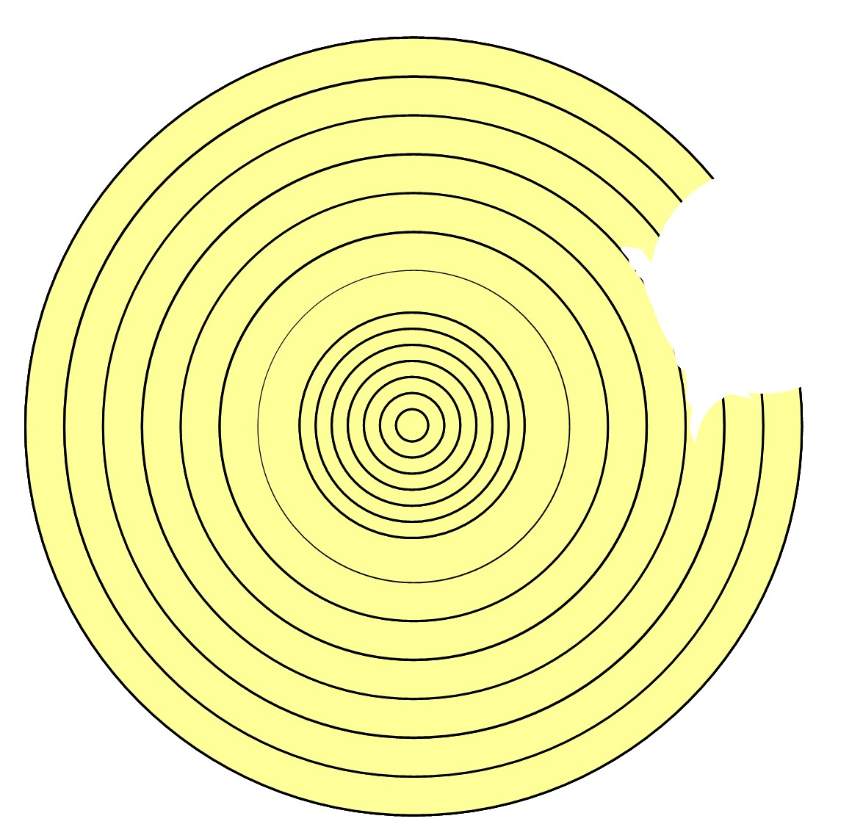

- Here is the scheme of the transversal cut of a trunk. What can you tell about that tree?

- How can we date the arrival of deer on the islands?

Prolonged and intense deer browsing affects tree and shrub growth and regeneration. What consequences for the forest ecosystem and forest industry can we imagine?

Response of vegetation to deer

Impact of deer on the vegetation

- Why did scientists expect the effect of deer on the vegetation to be important?

- What are the effects of prolonged browsing on the abundance and diversity of the vegetation?

Two habitats were studied (forest interior and shoreline). On islands where deer had been present for more than 50 years, the differences in vegetation structure and composition between these two habitats become very small. Why is it a threat to biodiversity?

Differences in browsing intensity between redcedars from Haida Gwaii and redcedars from the mainland

- Which balance determines the amount of defences a plant produces?

- Considering that plants of Haida Gwaii had never been exposed to such a browsing pressure before deer introduction, what did researchers expectabout their production of defences against herbivores?

- How did researchers show that redcedars from Haida Gwaii are less defended against herbivory than recedars from the mainland? Explain the different stages.

- How did researchers show that the production of chemical defences by redcedars is genetically determined? Explain the different stages.

All the species of an ecosystem evolve together. Why is the introduction of an alien species a threat to the native species?

Restoring the forests of Haida Gwaii

- What are the methods researchers used to assess the potential of recovery of the vegetation?

- What are the first results from the exclosure experiments?

- What additional information can a deer cull at the scale of an island bring?
Why was it important to compare the culled islands to control sites? Why was it important to set exclosures on the control islands?
What do the first results suggest about the potential for recovery of the ecosystem?

Is deer removal conceivable on the whole archipelago? Which other way to reduce deer browsing has been studied?

Response of animals to deer and squirrel

About invertebrates

- Invertebrate samplings were always carried out according to a precise protocol. Why was it important to use standardized sampling methods?

- What did the results suggest about the abundance and diversity of invertebrates in relation to deer browsing?

- Schematize the relationships between the affected invertebrates, vegetation and deer.

About songbirds

- Songbird samplings were always carried out according to a precise protocol. Why was it important to use standardized sampling methods?

- What did the result suggest about the abundance and diversity of songbirds in relation to deer browsing?

- How can squirrels also affect bird populations?

- Which bird species were the most affected? Why?

- Schematize the relationships between the affected songbirds, deer, vegetation, invertebrates and predators.

Why are alien species a threat to the balance of the whole ecosystem where they are introduced?

