Research Group on Introduced Species

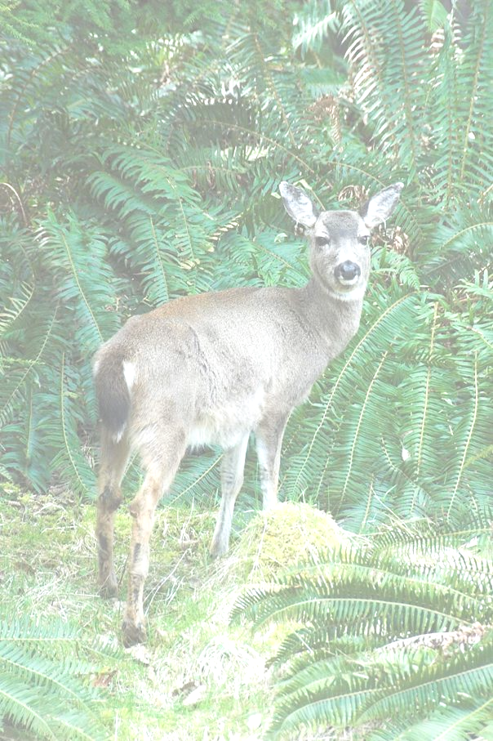
Deer introduction and the ecosystem of Haida Gwaii
School curriculum

2007

www.rgisbc.com
Contact: rgis@qcislands.net

Why a school curriculum? 2
What is wrong with deer on Haida Gwaii? – Elementary school 3
Haida Gwaii, a natural laboratory, a documentary – Junior high / High school 3
RGIS research on Haida Gwaii, a website – High school 4
The database 5

Why a school curriculum?

The issue of introduced species illustrates two topics that can be studied or discussed at school:
- The inter-relationships of organisms within an ecosystem
- The human impact on the environment

Having a close look at RGIS work with students is also a way to:
- help learning about the scientific approach,
- give an insight of the practical uses of different techniques and of the everyday life of a researcher when in the field,
- conduct a reflection about the issue of introduced species at different scales.

We propose 3 school materials:
- A curriculum intended for children between grade 4 and 7, based upon an illustrated booklet
- A curriculum intended for junior high/ high school students within the frame of a biology course, based upon a documentary film
- A curriculum intended for high school students within the frame of a biology course, based upon our website

Presentations of these materials are given in this document. The guidelines and media are available online or upon request from RGIS.

This document also shortly presents the RGIS database and its contents.

What is wrong with deer on Haida Gwaii? – Elementary school

What is wrong with deer on Haida Gwaii (2007) is a booklet intended for children between grade 4 and 7, in French and in English.

The first part focuses on the particular situation of Haida Gwaii (an archipelago), deer introduction and their dramatic impact on vegetation, and presents a few characteristics of insects’ and birds’ food habits and behaviours. Texts are short and go with abundant illustrations.

Using what they learned in this booklet, children are asked to complement a scheme of the relationships between the different elements of the forest ecosystem, without deer, and with deer. It leads then to another activity where children will give an interpretation of their schemes by thinking about the direct and indirect effects of deer introduction on Haida Gwaii. They will then be asked to think about why the impacts of introduced species are difficult to forecast, and why we must be careful with species introduction.

The booklet is available as a Powerpoint presentation and in a PDF version, in French and in English.
A printable document gathering the information provided by the booklet and the activities is available for distributing to the class, in French and in English.

Haida Gwaii, a natural laboratory, a documentary – Junior high / High school

Haida Gwaii, a natural laboratory (2003), by Michel Coqblin, 52 minutes, in French and in English
Copies available in the schools of the islands, at Laskeek Bay Conservation Society (Queen Charlotte), or upon request (rgis@qcislands.net).

In 1878, Europeans settlers introduced Sitka black-tailed deer on the Haida Gwaii archipelago. One century later, researchers, from France and Canada launched a multidisciplinary research program to assess the impacts of this introduction on the old-growth forest ecosystem and on the biodiversity of these islands.

The scientific approach in this field laboratory is described in a very educational way: problems are clearly posed, hypotheses are simply formulated, experiments and results are well detailed. Thus, the documentary can be used at different grades in junior high school and in high school. In addition, the documentary deals, through the case of deer introduction on Haida Gwaii, with the human impact on the environment and its consequences. This consideration is worth giving a though in the frame of a biology course.

We propose a guideline by Vincent Béranger, who teaches biology. This guideline can be used with students between grades 8 to 10-11. In French and in English.

RGIS research on Haida Gwaii, a website – High school

www.rgisbc.com, updated in summer 2007, in French and in English

RGIS website can be read at different levels.

After putting the issue of introduced species back in the context of Haida Gwaii (“Haida Gwaii” and “Introduced Species” and presenting shortly the research group and its field camp on Reef Island (Laskeek Bay) (“RGIS”), the web surfer can discover the work RGIS through 3 different approaches.

A “nutshell” approach (“What did we learn”)

This part gives an overview of the consequences of deer introduction on the vegetation, invertebrate communities and bird communities. It is accessible even without any scientific background and gone through within a few minutes.

It consists mainly in picture galleries and animations. This graphic approach intends to a quick understanding of the problem and of the main mechanisms involved.

This “nutshell” approach can be used as an introduction to more in depth work on the consequences of species introductions on Haida Gwaii.

A detailed approach to RGIS work (“Research”)

These pages give a concrete insight of RGIS work, through a detailed description of each experiment:
- the aim and scope are made explicit
- the protocols are described and schematized
- the results are presented through graphs and images and their analyses are progressively explained
- the main conclusions are drawn from the results presented and analysed in the page

These pages are intended to be accessible to anybody willing to go through the scientific approach behind the research. Each page (corresponding to an experiment) requires 10 to 15 minutes of reading. They are easily accessible to high school students within the frame of their biology course.

The ability of reading graphs is necessary, although no result is presented alone. When specific knowledge is necessary to the understanding of a protocol (for example, electrophoresis of DNA extracts) or to the reading of a graph (for example, a PCA), all the explanations are provided in the page.
The experiments are presented by field of investigation (history of deer colonization, response of vegetation to deer, response of animals to deer and squirrel, deer biology) and are clearly related to each other.

A “research” approach (“Publications”)

All the scientific publications are accessible online, either from the “research” pages, or directly in the “publications” section.
They are intended for a specialized public, but they can be used with high school students as examples of formal “research products”.

We propose a guideline for the use of RGIS website within a biology course. This guideline can be used with students between grades 10 to 12. In French and in English.

The database

The study of the impacts of non-native species introductions on the ecology of Haida Gwaii led to a large amount of data valuable for future monitoring, which are a repository of basic knowledge on forest ecology and thus a potential source of educational material.

The data available concern vegetation, invertebrates, birds and deer. It contains information about diversity, abundance and ecology as well as chemical and genetic analyses. All of these data cover different areas of Haida Gwaii, more or less affected by deer colonisation.

These data have been organized and formalized in order to preserve them and to make them clear and useful to different end-users, either specialized or non-specialized.

Within the same project, an image bank has also been created.

All this material is available upon request to the RGIS.

